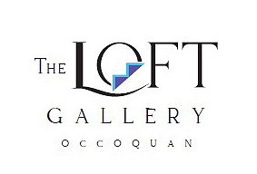
Artist Application
313 Mill St., PO Box 402, Occoquan, VA 22125 | 703-490-1117
LoftGallery.Occoquan@gmail.com
Tuesday-Friday 11am-4pm
Saturday 11am-5pm Sunday Noon-5pm

Date: ____________

Name: (pls print) ________________________________________________________
Business name _{(can be your name)} ______________________________________________
Contact telephone #s (primary) ____________________________ (H or C)
Secondary tel # ________________________________ (H or C)
Address street ________________________________________________________
City/State/zip__________________________________________________________
Email: _______________________________________________________________
Website/Blog/Facebook/other social media you use to promote your art
______________________________________________________________________
______________________________________________________________________
______________________________________________________________________
Medium(s) _____________________________________________________________
Do you have artwork you have completed in the last 3 months? ___________________
If juried into the gallery would you be able to have a solo show in 6 months? _________
Art group membership(s) ________________________________________________
______________________________________________________________________
______________________________________________________________________
Attach your resume and Artist statement (statement no more than 1-page). Include 3 photographs of your most recent artwork. Email your application and accompanying documents to the Loft Gallery: loftgallery.occoquan@gmail.com

**Please note Gallery artists are required to work 1-2 days a month, attend a monthly meeting, change/hang your wall 1st Monday of the month, and participate in other Gallery events throughout the year.

